Department of Mechanical Engineering

EMCH 368
MECHATRONICS

Lab 03
Sound

Last Edited: 6/23/2024 by T. Russo

A piezo is a small element that vibrates when it receives electricity. When it moves, it displaces the air around it, creating sound waves. If your piezo has a + marked on one end, this is the one that is supposed to connected to power. If not, this is not a polarized component. Make sure to use the buzzer that does NOT have a sticker on it.

A passive infrared (PIR) sensor uses two slots, which are made of a material that is sensitive to IR. The sensor works by using a differential change between the two slots detected IR. When one slot detects a warm body from a human or animal, the first slot will detect this and return a higher output then the other slot. This difference will tell the sensor that there is something moving in its view.

Exercise 1: Creating a Light Theremin

A theremin is a musical instrument that makes sound based on the movements of a musician’s hands around the instrument by reading capacitive changes on the sensor antennae. In this lab, you will develop a light-sensitive theremin that uses a phototransistor to detect the amount of light. You might have noticed that in the previous lab, the ADC reading on the serial monitor did not range all the way from 0 to 1023. The fixed resistor connecting to ground limits the low end of the range, and the brightness of your LED limited the high end of the range. For the theremin, you will learn to calibrate a sensor to take advantage of as much of the ADC’s range as possible.

Your goal is to create a circuit that meets the following criteria:
- Create a theremin that uses a phototransistor to detect light
- The sound will be output by a piezo and will be controlled by the light intensity detected by the phototransistor
- Calibrate the piezo based on the voltage range of the phototransistor

Materials:
- 1 set of long red and black jumper wires
- 1 passive buzzer (piezo)
- 1 photoresistor
- 1 220-ohm resistor

Building the Circuit:
- Connect a red wire to the 5V pin on the ELEEGO and put the other end in one of the long (+) bus lines in the breadboard.
- Connect a black wire to the ground pin on the ELEEGO to the adjacent long (-) bus line on the breadboard.
- Connect one end of the piezo to ground, and the other to digital pin 8 on the ELEEGO
- Place the photoresistor on the breadboard, connecting the one leg to the (+) bus.
- Connect the other leg to the ELEEGO’s Analog In pin A1 Also connect this end to ground with a 220 ohm resistor.
- Connect USB power to the ELEEGO.

Exercise 1 Circuit

Writing the Program:

Create the variable photoRes to be the photoresistor on analog pin A1. Create a constant named piezo. Use this pin to send different levels of voltage to the piezo. In the void setup(), set the Piezo pin as an output. Begin the serial so we can print the pitch to monitor later.

The variable pitch will be the frequency of the note that the piezo will play. The value of the pitch will be determined by mapping the ADC reading from the photoresistor to a frequency range of 50 to 4000 Hz.
The tone() function plays the sound. It needs the pin on which to play the sound (pin 8), the pitch, and the duration (try 20 milliseconds to start).

Using the Circuit:
When you begin the program, the piezo will begin making noise! As you change the amount of light that hits the photoresistor, the pitch of the piezo should change.

Exercise 2: Keyboard Instrument
Now that you have an idea of how sound is created electronically, let’s apply it to a more familiar application: a keyboard instrument. By assigning buttons to play a specific frequency on the piezo, you will create a 4-button musical instrument. While it’s possible to simply hook up each switch to different digital inputs, in this project, you’ll be constructing something called a resistor ladder. This is a way of reading the number of switches using an analog input instead. You will hook up 4 pushbuttons in parallel, each connected to power with its own resistor. When you press each button, a different voltage level will pass to the input pin.

Your goal is to create a circuit with the following criteria:
- Create a musical keyboard using 4 pushbuttons that each play a unique frequency
- Connect the pushbuttons in a resistor ladder that connects to a single analog input pin
- Use a piezo to play sounds according to the states of the pushbuttons

Materials:
- 1 set of long red and black jumper wires
- 1 piezo
- 4 switches
- 1 220-ohm resistor
- 2 10k-ohm resistors
- 1-megohm resistor

Building the Circuit:
- Remove USB power before tampering with the circuit
- Clear all the components from the breadboard except the lines to the power and ground buses.
- Connect one end of the piezo to ground and the other end to digital pin 8.
- Place the switches as shown below. Connect the first one directly to power. Connect the second, third, and fourth switches to power through a 220-ohm, 10-kilohm, and 1-megohm resistor, respectively.
- Connect all the switches’ outputs together in one junction. Connect this junction to the ground with a 10-kilohm resistor. Also connect to it to analog pin A0. Each of these resistors acts as a voltage divider.
- Plug in USB power and upload your code.
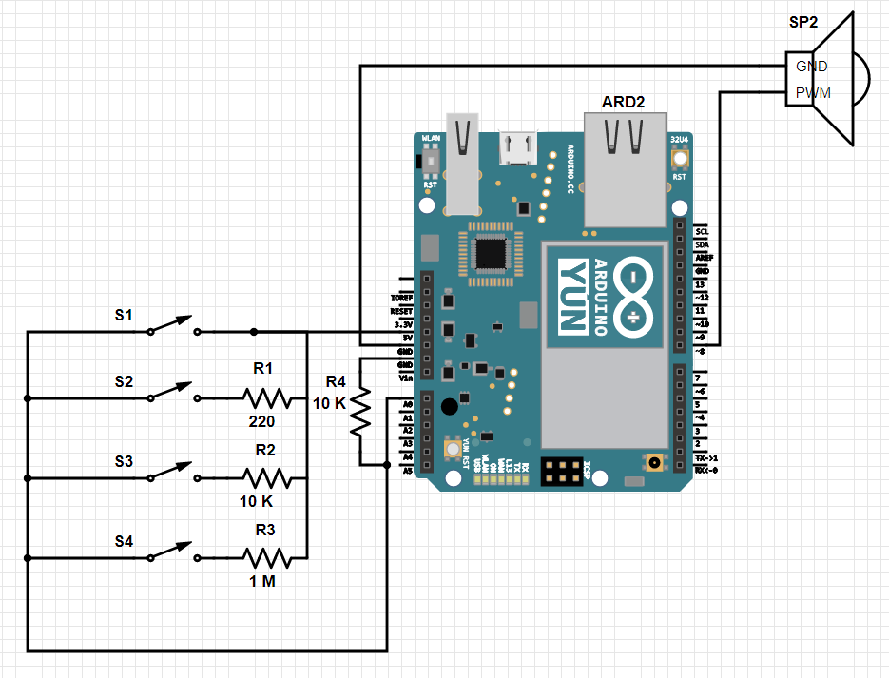
+-
Exercise 2 Circuit

Writing the Code:

Set up an array of four notes using the frequencies listed above. Notice how an array is created by using square brackets at the end of the array name. The items in the array are listed inside curvy brackets.
Start the serial communication with the computer and set the buttons as an input.
Begin the program by having the microcontroller get an ADC reading from pin A0 and print it in the serial monitor.

Set up a series of if statements that will tell the piezo what frequency to play. If the value of A0 matches one of your if statements, you can tell the ELEEGO to play a tone. For example, if the first button is pressed, the reading should be 1023 (because there is no resistor) and the first note in the array should be played. notes[0] means that the 0th number in the array will be returned. Keep in mind that computers start counting at 0, so really it will return the first number in the array, 262.
Using the Circuit
Whenever you press each button, a different note will play within the same musical key. If you do not hear any sound, check the serial monitor. It should display the ADC reading. If you see a number that is far outside any of the ranges you specified in the code, you may have used the wrong resistor.
It is possible your circuit is a little “noisy” and the ADC values fluctuate some while the button is being pressed. To accommodate for this variation, you may need to adjust the bounds of your if statements.

Exercise 3: PIR Motion Sensor
PIR Sensors are used in many different applications. To start off with an introduction to PIR Motion sensors, you are asked to use one to light up an LED when it detects a person. Pay attention specifically to the pin assignments for the PIR Sensor as not every sensor has the same pin layout.
For this exercise, you must create a circuit that incorporates a PIR Motion sensor and an LED. When someone walks in front of the sensor, it should turn on an LED to inform us that it detects someone.

Materials:
- 1 set of long red and black jumper wires
- 1 PIR Motion Sensor
- 1 220-ohm resistor
- 3 Female to Male wires
- 1 LED

Building the Circuit:
- Remove USB power before tampering with the circuit
- Clear all the components from the breadboard except the lines to the power and ground buses.
- Connect the left pin of the PIR Sensor to ground. Connect the right pin to the (+) bus, and the middle pin to digital Pin 2.
- Place your LED on the breadboard, connect the cathode to ground with the 220-ohm resistor, and connect the anode to digital Pin 13.
- Plug in USB power and upload your code.
(For those using tinkerCad, this diagram displays what the physical circuit should look like using the given physical PIR Sensor, the digital tinkerCad PIR Sensor has its left pin connected to a digital Pin, the middle to power and right to ground.)

Writing the Code:
First assign pirSensor and LED to a certain digital Pin, this can be whatever you want as long as it matches what your physical circuit is connected to. In this case our PIR Sensor is on digital Pin 2, and the LED on 13. In void setup(), assign the sensor as in INPUT as we are taking in the information from the sensor, and the LED as OUTPUT since we are sending out power to it. Also begin Serial as we will be using this later as a log for when the motion sensor detects and no longer detects motion.
Using digitalRead() in the if statements allow us to check our PIR sensor and see whether it detects any motion, which would return a HIGH value. If motion is detected we can write to the LED pin, turning it on. We will also then log the detection in the serial monitor by printing that motion has been detected. If motion is not detected, then the else statement will turn the LED off if it was on previously, or it will continue to keep it off and then log it in the Serial Monitor.

Challenge: Motion Alarm System

Various alarm systems have different techniques for detecting whether there is an intruder. One of these, the one we challenge you to create, expects there to be no motion when the system is running. If the system detects motion, it will start the alarm, log when the intruder was detected and will have a flashing light. The alarm can be turned off by using a code.
For this challenge, you will have to create the same system with one change being the alarm can be turned on and off with the one button, so do not worry about any code. Your requirements for this challenge are listed below:

Requirements:
- If motion is detected, the alarm (buzzer) goes off and an LED will start flashing alerting anyone of the intruder.
- The alarm can be turned off by the press of a button.
- Everything must be logged in to the Serial Monitor, from the system status (such as on or off) and sounding the alarm.

Lab 3 Code Appendix (in order of appearance):
while(condition) - The while loop is used to repeat a block of code enclosed in curly brackets. The loop will continue if the condition inside the while loop’s parenthesis is true.

millis() – reports how long the microcontroller has been running (in milliseconds) since it was last powered on or reset

map (value, fromLow, fromHigh, toLow, toHigh) - this functions scales values for you between two different ranges of numbers. For example, the microcontroller’s ADC outputs 0-1023 for a range of 0-5 volts. If you wanted to know how many volts an ADC value of 150 corresponds to, you could use map() in the following way: map(150, 0, 1023, 0, 5)

tone(digital output pin #, frequency, duration) – generates a square wave of the specified frequency. A duration can be specified, otherwise the wave continues until noTone() is called. The output pin can be connected to a piezo buzzer or a speaker to play tones.

Arrays – Arrays are a handy tool for keeping a list of values under one variable name. To declare an array, start as you would with a regular variable, but follow the name with square brackets: []. After the equals sign, list your values in curly brackets.

noTone() – stops the generation of a square wave triggered by tone().

Lab 3 Grading Rubric:
- Exercise #1 works (10 points)
- Exercise #2 works (5 points)
- Exercise #3 works (10 points)
- Challenge #1 works (15 points)
- Comprehension Questions (10 points)
Grade distribution template (total 50 points)

